Front End Engineering-II

Project Report Semester-IV (Batch-2022)

DRAWING APP



**Supervised By:**

Raveesh Samkaria

**Submitted By:**

Tanisha

Roll Number: -2210990891

Group - 13

## Department of Computer Science and Engineering Chitkara University Institute of Engineering & Technology,

**Chitkara University, Punjab**

FEE-II, 22CS0014

1

# Abstract

The project is a web-based drawing application named "SimplyDraw," designed and implemented using HTML, CSS, and JavaScript technologies. The application provides users with a digital canvas and a variety of drawing tools to unleash their creativity and create artwork online.

The HTML structure of the application includes elements such as canvas for drawing, tools board with options like brushes, erasers, shapes (rectangle, circle, triangle), color selection, and navigation menus for user interaction.

The JavaScript functionality of the application enables users to perform various actions:

1. Drawing Tools: Users can select different drawing tools such as brushes and erasers, adjust brush sizes, and choose colors from a color palette.

2. Shape Drawing: The application allows users to draw shapes like rectangles, circles, and triangles with customizable properties such as fill color and stroke.

3. Undo/Redo: Undo and redo functionalities are implemented using stacks to manage the state of the canvas, enabling users to revert and redo drawing actions.

4. Save and Clear: Users can save their artwork as an image file and clear the canvas to start afresh.

5. Responsive Design: The application is designed to be responsive, ensuring a consistent user experience across different devices and screen sizes.

Overall, SimplyDraw provides an intuitive and interactive platform for users to express their creativity, experiment with different drawing tools, and create digital artwork conveniently within a web browser.

FEE-II, 22CS0014

2

# Table of Contents

|  |  |  |
| --- | --- | --- |
| **Sr.no** | **Section** | **Page No.** |
| **1** | **Introduction** | 4 |
| **2** | **Problem Statement** | 5 |
| **3** | **Technical Details** | 6 |
| **5** | **File Structure** | 7 |
| **6** | **Code** | 8-14 |
| **7** | **Desktop view** | 15-17 |
| 8 | **Mobile view** | 18-20 |
| 9 | **Reference** | 21 |

FEE-II, 22CS0014

3

# Introduction

In the digital era, artistic expression has found a new canvas through web-based applications. The project "SimplyDraw" embodies this concept by offering users a platform to unleash their creativity through an interactive drawing application accessible via web browsers. This introduction outlines the features, functionality, and significance of SimplyDraw in providing a digital playground for artists of all levels.

SimplyDraw is a comprehensive web application built using HTML, CSS, and JavaScript technologies. It integrates a range of tools and functionalities to facilitate digital drawing and artwork creation. The core components of SimplyDraw include:

1. **Canvas for Drawing:** The application provides a digital canvas where users can draw, sketch, and paint using various tools and techniques.

2**. Drawing Tools:** Users can choose from a selection of drawing tools such as brushes, erasers, and shape tools (rectangle, circle, triangle) to create diverse artwork.

3. **Color Customization:** A color palette and color picker allow users to select and apply a wide range of colors to their drawings, offering flexibility and creativity.

4**. Undo/Redo Functionality:** SimplyDraw includes undo and redo functionalities, enabling users to revert or redo drawing actions, providing a seamless editing experience.

5. **Saving and Clearing**: Users can save their artwork as image files for sharing and archival purposes. Additionally, a clear canvas option allows for starting new drawings easily.

6. **Responsive Design:** The application is designed to be responsive, ensuring optimal user experience across devices and screen sizes, making creativity accessible anytime, anywhere.

SimplyDraw holds significance as a digital art platform for several reasons:

1. **Accessibility:** It eliminates barriers to artistic expression by offering a user-friendly interface accessible via web browsers on desktops, laptops, and mobile devices.

2. **Creativity Enhancement**: With a diverse range of drawing tools, colors, and features, SimplyDraw empowers users to explore and enhance their creativity, whether they are beginners or experienced artists.

3. **Collaboration and Sharing:** The ability to save artwork and share it with others fosters collaboration, feedback, and community engagement among artists.

4. **Educational Value:** SimplyDraw can serve as an educational tool for teaching digital art concepts, techniques, and practices in classrooms or online learning environments.

5. **Entertainment and Relaxation:** Beyond its artistic utility, SimplyDraw offers a space for entertainment, relaxation, and stress relief through art creation.

Overall, SimplyDraw represents a modern approach to digital artistry, combining technology, creativity, and accessibility to inspire and enable artistic expression in the digital age.

FEE-II, 22CS0014

4

# Problem Statement

The development of the SimplyDraw web-based drawing application aims to address several challenges and needs in the realm of digital art creation and expression. The problem statement encapsulates these challenges and sets the stage for understanding the motivations behind creating SimplyDraw.

**Challenges and Needs:**

1. **Accessibility:** Traditional digital art software often requires downloads, installations, and specific hardware configurations, limiting accessibility for users who prefer a web-based, platform-independent solution.

2. **User-Friendly Interface:** Many existing digital art tools can be complex and overwhelming for beginners or casual artists, necessitating a user-friendly interface that caters to a wide range of skill levels.

3. **Tool Diversity:** Artists often require a diverse set of drawing tools, color options, and customization features to fully explore their creativity and express their artistic vision.

4**. Undo/Redo Functionality:** The lack of efficient undo and redo functionalities in some digital art applications can hinder the editing and revision process, leading to frustration and workflow disruptions.

5. **Collaborative and Sharing Features:** Artists may seek platforms that facilitate collaboration, feedback, and sharing of artwork with others, promoting community engagement and interaction.

6.**Responsive Design:** In an era of diverse devices and screen sizes, the need for a responsive design that ensures a consistent and optimal user experience across platforms is paramount.

**Objectives of SimplyDraw:**

Based on these challenges and needs, the objectives of SimplyDraw are as follows:

1. **Accessibility:** Provide a web-based drawing application accessible on various devices without the need for downloads or installations.

2.**User-Friendly Interface:**  Design an intuitive and user-friendly interface that caters to both beginner and experienced artists, ensuring ease of use and navigation.

3. **Tool Diversity:** Offer a diverse range of drawing tools, color options, and customization features to empower users to explore their creativity and create artwork with versatility.

4.  **Undo/Redo Functionality:** Implement efficient undo and redo functionalities to enhance the editing and revision process, providing a seamless user experience.

5. **Collaborative and Sharing Features:** Enable users to save, share, and collaborate on artwork, fostering a sense of community and engagement among artists.

6. **Responsive Design:** Develop SimplyDraw with a responsive design approach, ensuring optimal performance and usability across devices and screen sizes.

FEE-II, 22CS0014

5

# Technical Details

1.**HTML Structure:**

- The HTML code defines the structure of the SimplyDraw web application.

- It includes elements such as canvas for drawing (`<canvas>`), tools board (`<section>`), navigation menus (`<nav>`), buttons (`<button>`), and input elements for color selection and tool options.

2. **CSS Styling:**

- The CSS stylesheets (`style.css`, `output.css`, and external libraries) are linked to provide visual styling and layout formatting.

- CSS classes and styles are applied to create a responsive and visually appealing interface for the drawing application.

3. **JavaScript Functionality:**

- The JavaScript code (`main.js` and `new.js`) provides the interactive functionality and logic of SimplyDraw.

- It handles user interactions, tool selection, drawing actions, color customization, undo/redo functionality, canvas management, and event listeners for various elements.

4**. Canvas Drawing:**

- The code uses the HTML `<canvas>` element and the Canvas API in JavaScript (`getContext('2d')`) to create a digital canvas for drawing.

- Drawing functions are implemented for tools like brushes, erasers, and shapes (rectangle, circle, triangle).

5. **Tool Selection and Customization:**

- Users can select different drawing tools (brush, eraser, shapes) by clicking on corresponding buttons (`toolBtns`).

- Tool properties such as brush size (`sizeSlider`), color selection (`colorBtns`, `colorPicker`), and fill options (`fillColor`) are customizable.

6**. Undo/Redo Functionality:**

- Undo and redo functionalities are implemented using stacks (`undoStack` and `redoStack`) to store and manage canvas state snapshots.

- Buttons (`undoBtn` and `redoBtn`) allow users to undo or redo drawing actions with ease.

7. **Save and Clear Canvas:**

- Users can save their artwork as image files (`saveImg`) for download and sharing purposes.

- A button (`clearCanvas`) is provided to clear the canvas and start a new drawing.

8. **Responsive Design:**

- The application is designed to be responsive (`max-sm` classes) for optimal viewing and functionality across different devices and screen sizes.

- Media queries and responsive layout techniques are used to adjust the interface elements based on the device's screen width

9. **External Libraries:**

- External libraries such as Remixicon (for icons) and Font Awesome (for icons) are linked to enhance the visual presentation and user experience.

10. **Event Handling and User Interaction:**

- Event listeners (`addEventListener`) are used to handle user interactions such as mouse clicks, mouse movements, and input changes.

- Interaction with tools, color selection, canvas drawing, and other actions are managed through event handling in JavaScript.

FEE-II, 22CS0014

6

# File Structure: -

* **index.html:** This is the main HTML file that serves as the entry point of the web application. It contains the structure of the application's user interface, including the canvas, tools, navigation menus, and content sections.
* **input.css**: This CSS file likely contains styles and rules that are used during development or preprocessing stages. It might include styles that are later processed and outputted to the output.css file.
* **new.js**: This JavaScript file contains the logic and functionality of the SimplyDraw application. It handles user interactions, drawing actions, tool selection, color customization, undo/redo functionality, and other features.
* **icons folder**: This folder likely contains icon files (such as .svg or .png files) used in the user interface for buttons, tools, or navigation elements. These icons enhance the visual representation of the application.
* **images folder**: This folder contains image files used within the application, such as logos, background images, or any other graphical assets required for the user interface or content sections.
* **output.css**: This CSS file contains the final compiled or processed styles that are applied to the HTML elements of the web application. It includes styles from the input.css file and possibly additional styles from external libraries or frameworks.

Overall, this file structure organizes the various components (HTML, CSS, JavaScript, icons, and images) of your SimplyDraw project, ensuring a systematic and manageable approach to development 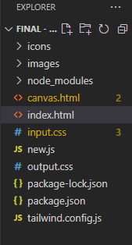

FEE-II, 22CS00

7

**Code:-**

**HTML:-**

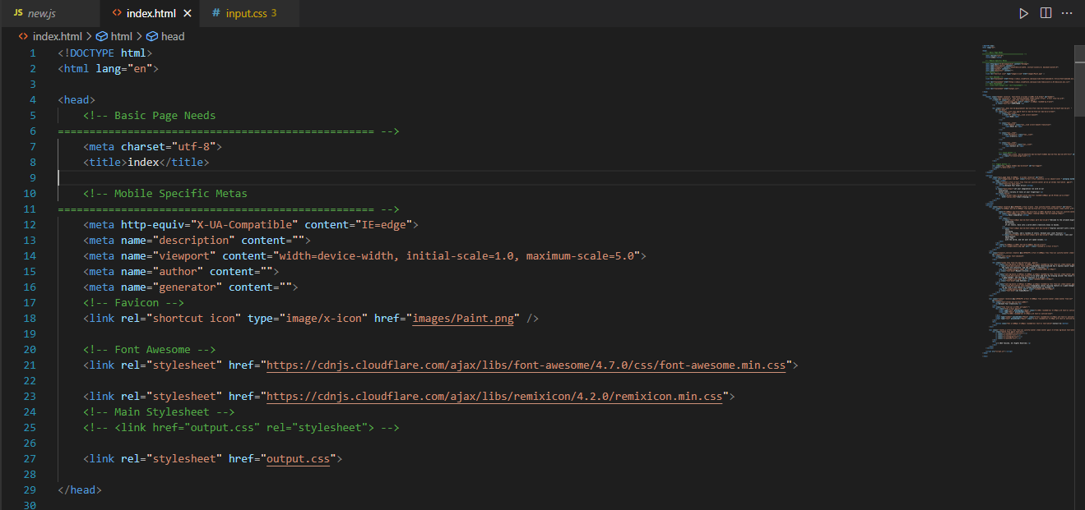

**Head Tag**

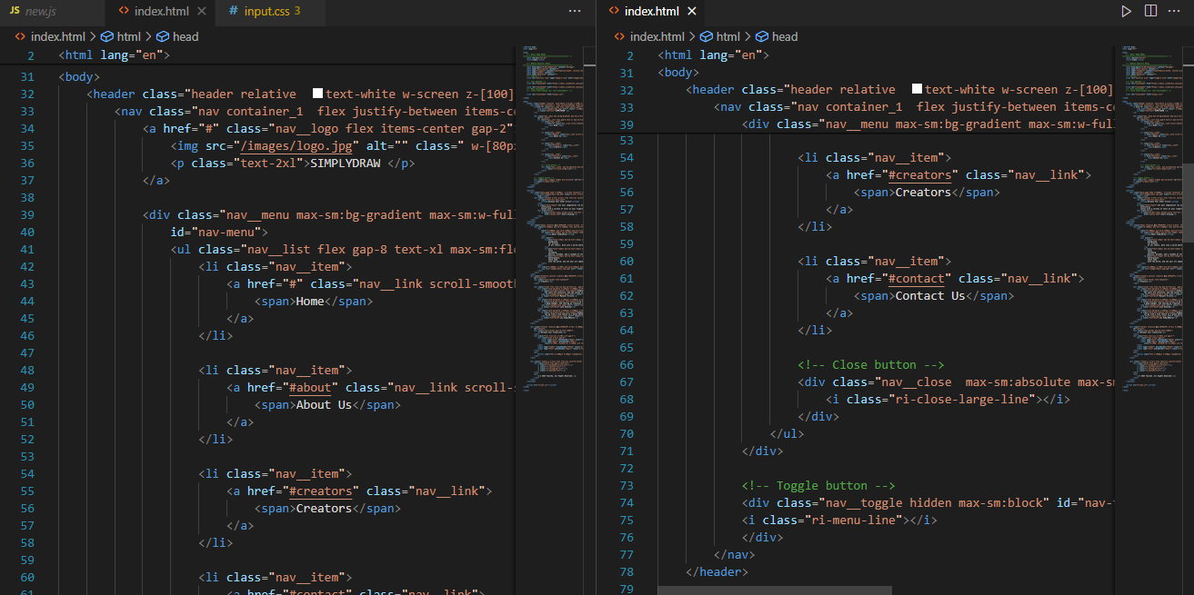

**Navbar**

FEE-II, 22CS001

8

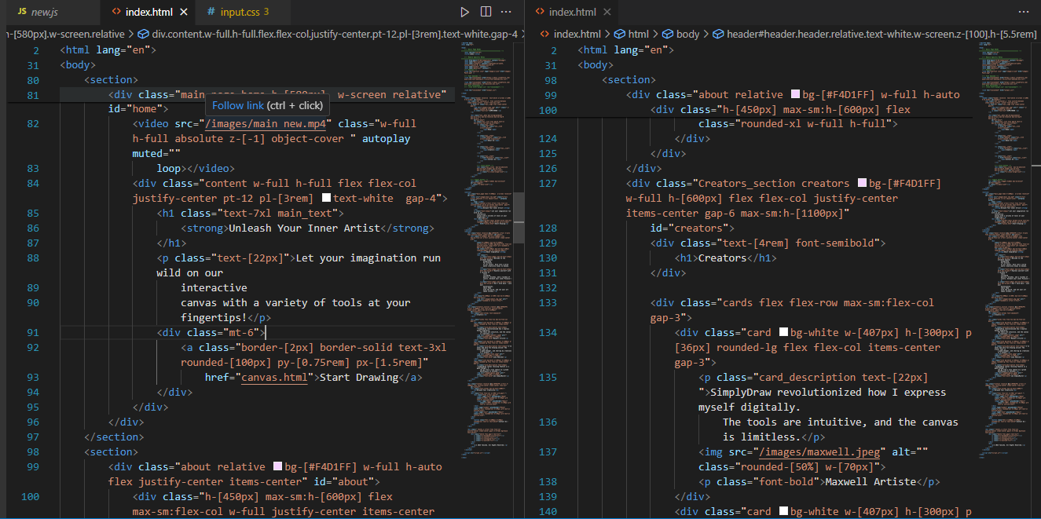

**Landing page**

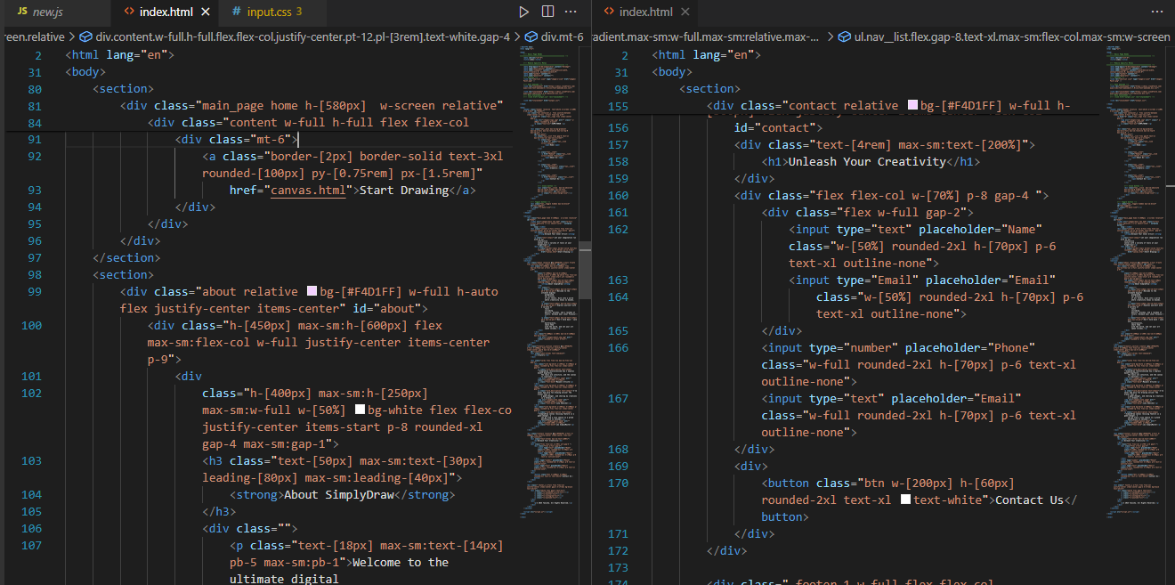

**Landing page**

FEE-II, 22CS001

9

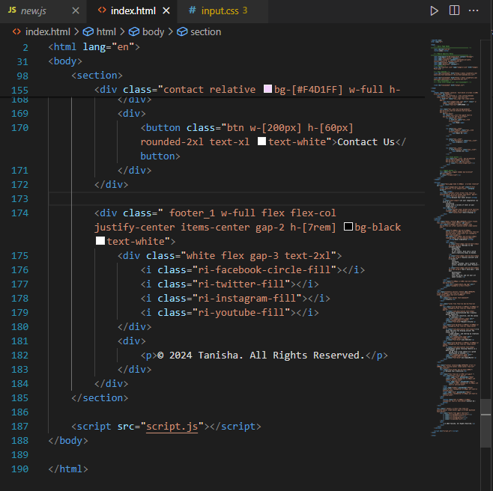

**Landing page**

FEE-II, 22CS0014

10

**Input.css:-**

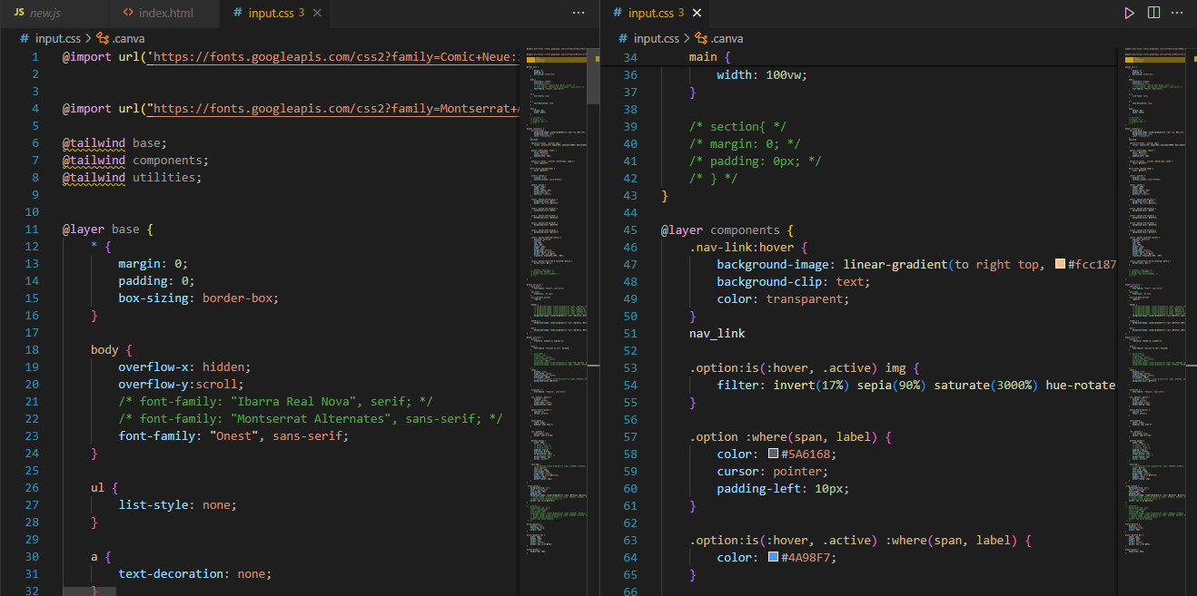

**CSS: Figure 1**

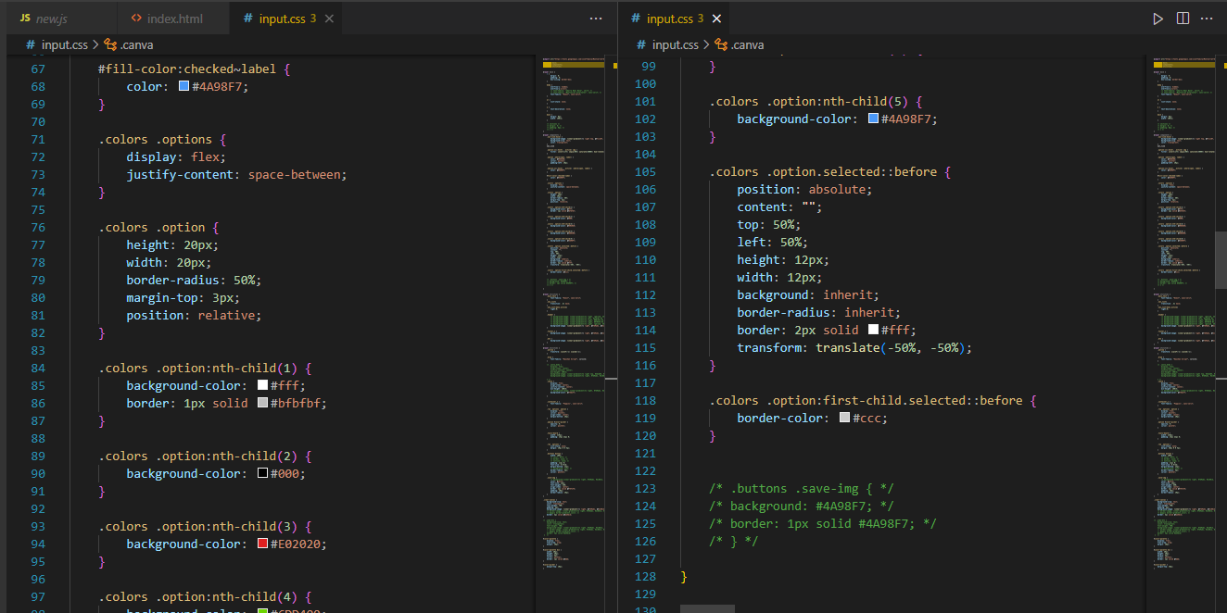

**CSS: Figure 2**

11

FEE-II, 22CS0014

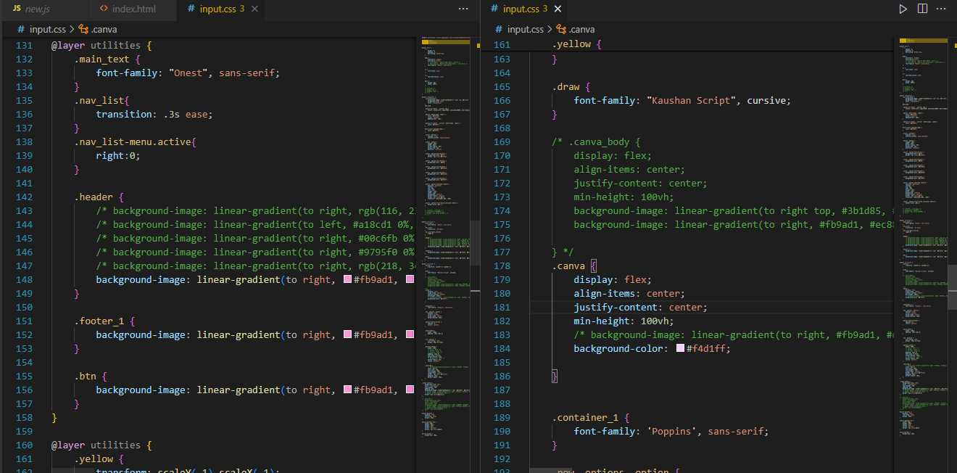

**CSS: FIGURE-3**

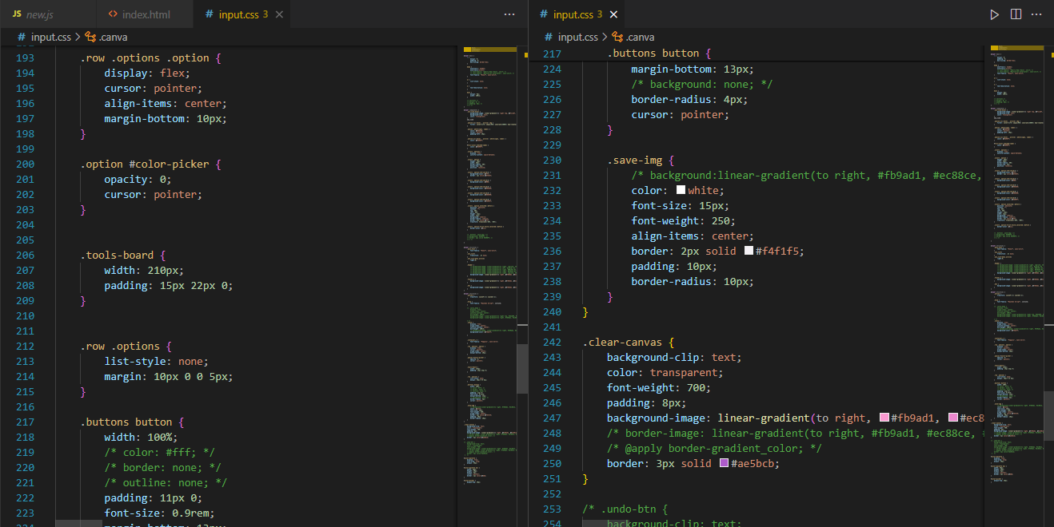

**CSS:Figure-4**

FEE-II, 22CS0014

12

**Javascript:-**

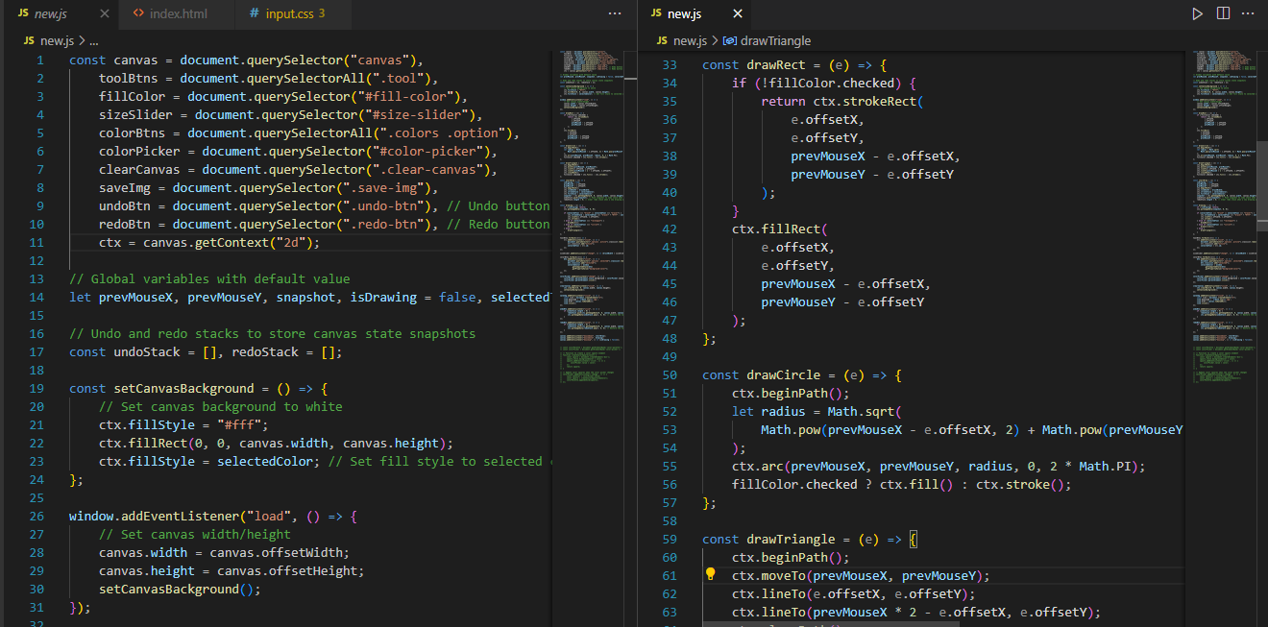

**Javascript: Figure 1**

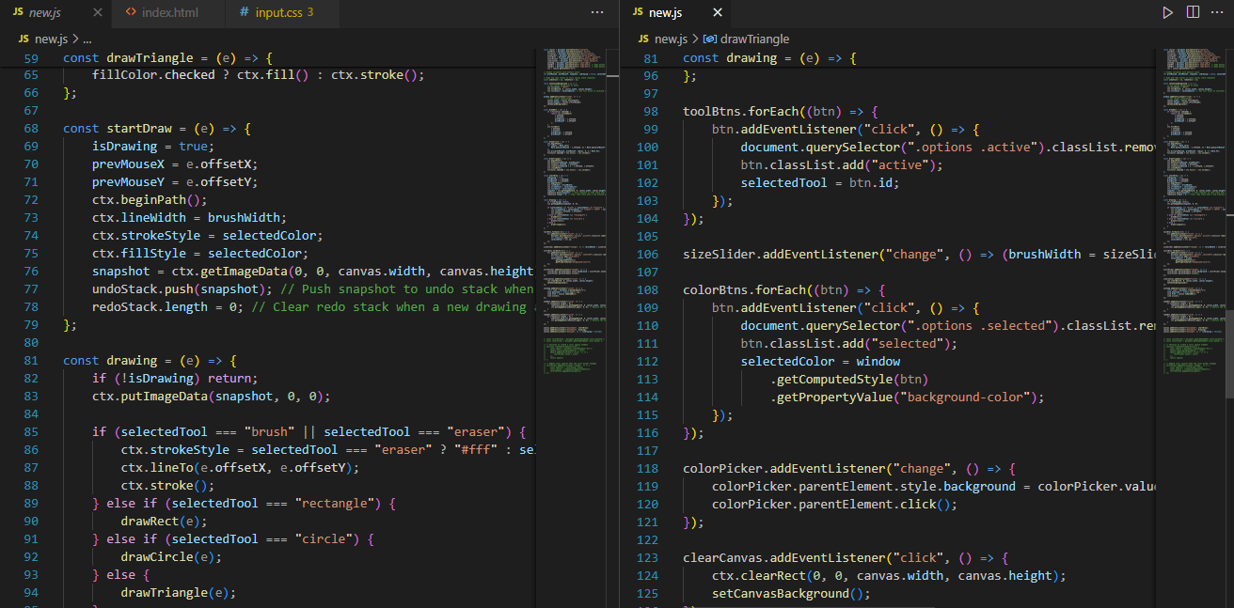

**Javascript: Figure 2**

FEE-II, 22CS0014

13

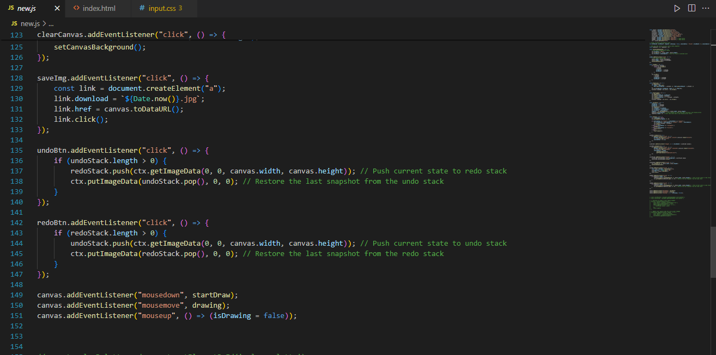

**Javascript: Figure- 3**

FEE-II, 22CS0014

14

**Desktop View Output:-**

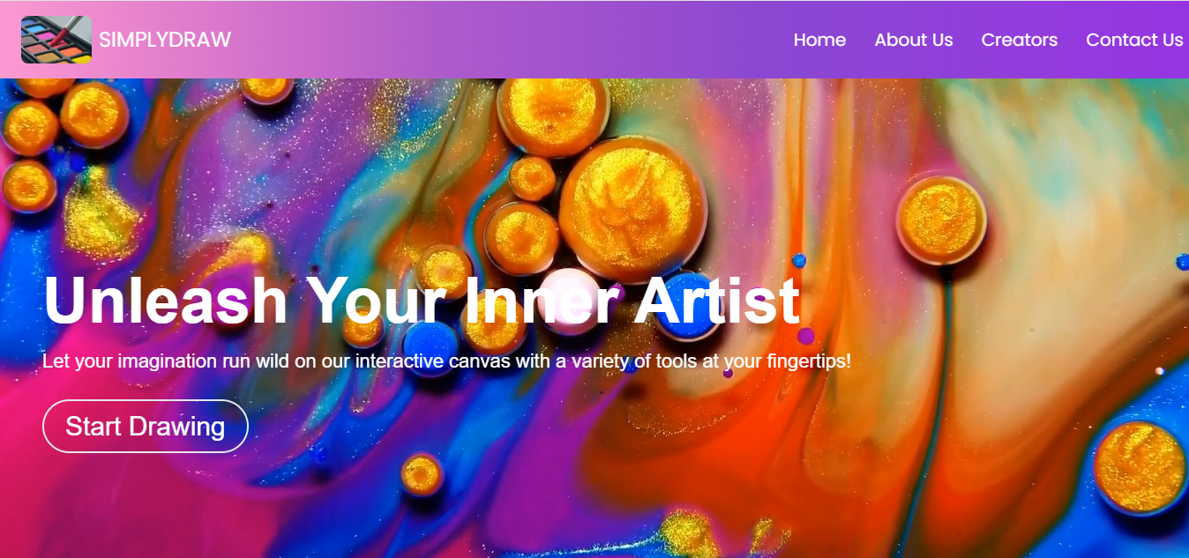

**Landing page**

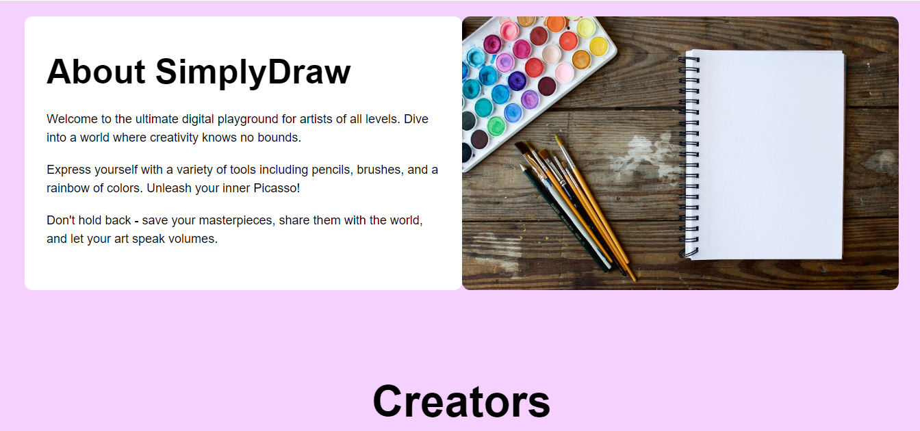

**Landing page : About Section**

FEE-II, 22CS0014

15

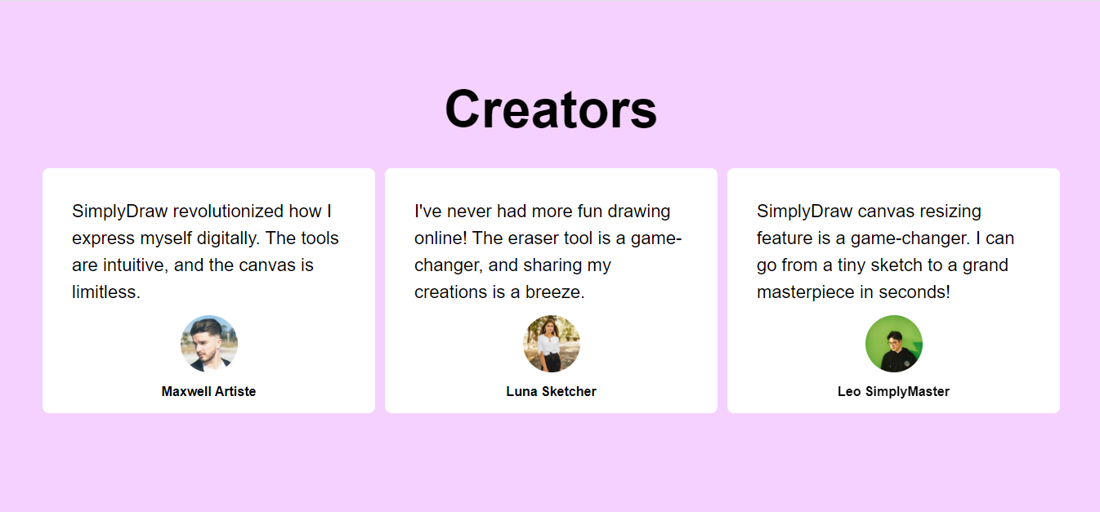

**Landing page: Creators section**

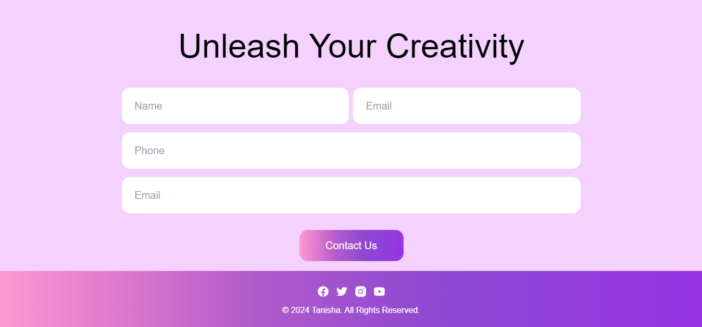

**Landing page: Contact us section**

FEE-II, 22CS0014

16

**DRAWING PAGE:-**

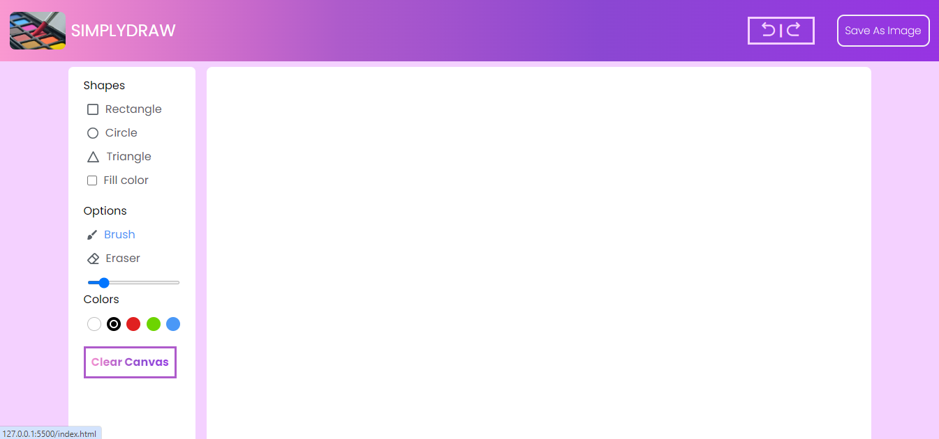

**Drawing page**

17

FEE-II, 22CS0014

**Mobile View Output:-**

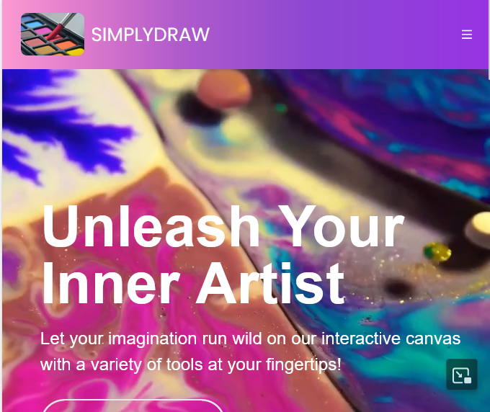

**Landing page**

FEE-II, 22CS0014

18

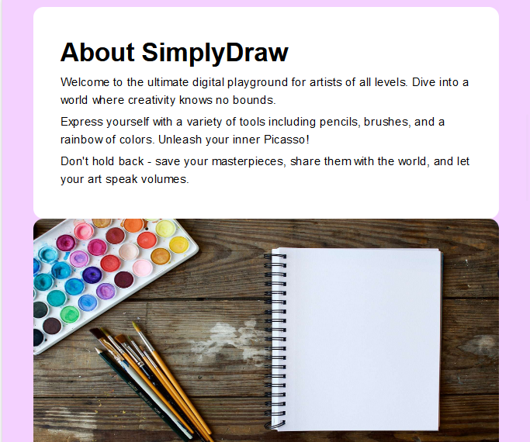

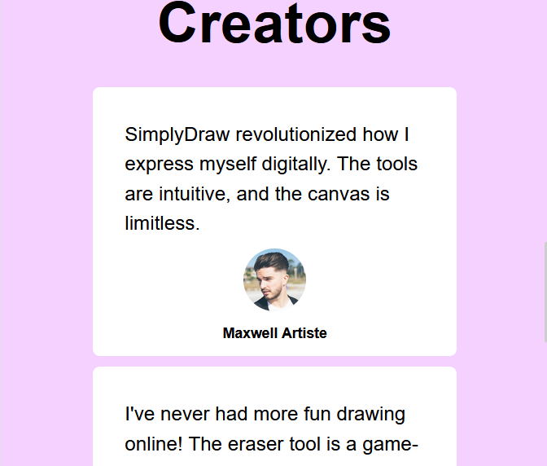

FEE-II, 22CS0014

19

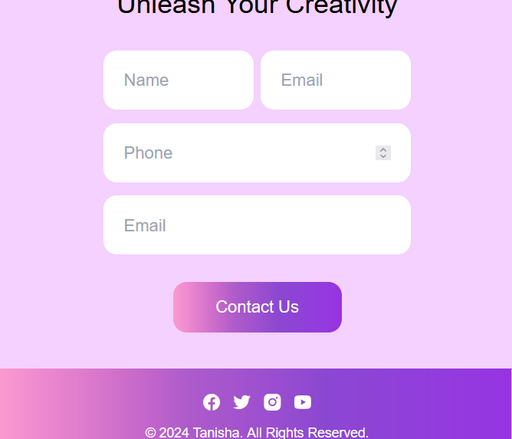

**Contact us**

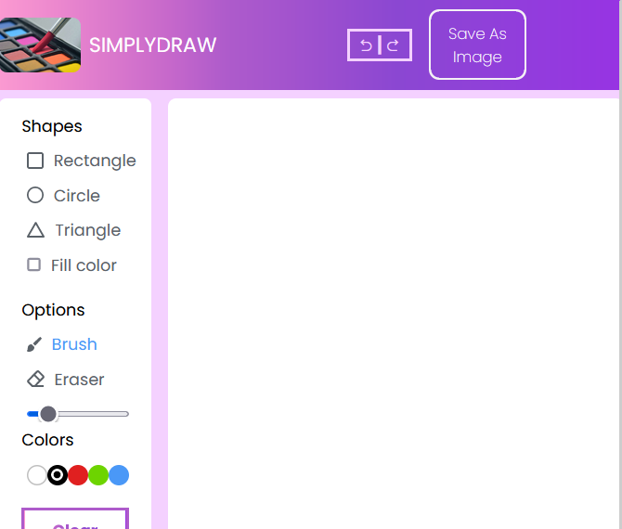

**Canvas Page**

FEE-II, 22CS0014

20

**References:-**

1. Tailwind Documentation:-<https://tailwindcss.com/>
2. Remix icon:- <https://remixicon.com/>
3. Font awesome:- <https://fontawesome.com/>
4. Google font:- <https://fonts.google.com/>

FEE-II, 22CS0014

21